Heart rhythm pilot – patient information

It is your decision whether to take part in this heart rhythm check or not. This information will help you decide.

Why are we offering heart rhythm checks?
Atrial fibrillation (AF) is the most common cause of irregular heartbeat, known as cardiac arrythmia. There are 500,000 people with undiagnosed AF in the UK.

AF significantly increases the risk of developing a blood clot in your heart, which can travel to your brain and cause a stroke.

The good news is that these risks can be significantly reduced with the correct course of treatment.

Who are we inviting to take part?
Heart rhythm checks are being offered to people who may be at higher risk of developing AF by Ipswich and West Suffolk Hospitals.

The chances of developing AF increase as you get older. It is much more common from age 65+. Having other conditions also makes AF more likely. They include:
- other diseases of the heart such as coronary heart disease and heart failure
- high blood pressure
- an overactive thyroid
- lung disease
- chest infections like pneumonia
- alcohol or drug misuse
- vascular disease
- diabetes
- any previous stroke or transient ischaemic attack (TIA)
- a diagnosis of dementia

What happens if I would like to take part?
We are using new technology to help identify AF in people. This means you will need access to your own smartphone or be able to ask a family member/carer who has a smartphone to help.

We advise you to watch these videos for information about using the FibriCheck app https://youtu.be/5bQCVWG-t7I and to hear from the doctors taking part in the project https://youtu.be/Po87yI2LAjI

How will the heart rhythm check work?
- You will receive an automated text message with a link to further information. When you have confirmed that you would like to take part, you will receive a second text message with a link to download the Fibricheck app free of charge. This link is unique to you and must not be shared.
- You will need to create and activate your account. At the end of this leaflet there are instructions on how to do this.
- Use the FibriCheck to monitor your heart rhythm twice a day for seven days.
- You can personalise your notifications. The default is set to one or two reminders a week.
- To use the app, simply place your finger on your smartphone camera, located at the back of the phone, for 60 seconds and your heart rhythm will be recorded.
- After seven days your results will be reviewed by a specialist nurse or doctor at Ipswich or West Suffolk Hospital.
- If further investigation is required, you will be contacted directly via letter providing clear instructions on the next steps, which will include using a different device at home to gather more information. This device will be sent to you free of charge. You will then be contacted by one of the specialist clinical team to discuss the next steps which might involve taking medication.

Please note that if you wish to continue using the FibriCheck app after the seven day period, this would be at your own cost and results will not be automatically shared with your clinician.

The goal of the FibriCheck heart health check is to help you and your doctors to understand your heart health. FibriCheck is a screening tool, not a diagnosis. A diagnosis is always made by the treating doctor who is able to consider your complete medical history and advise on the best course of action for you.

It's important to note that some people experience an irregular heart rhythm every now and then, rather than regularly or constantly. Some people may have a normal heart rhythm and then suddenly get an abnormal one, this is known as paroxysmal atrial fibrillation.

Both frequent and infrequent irregular heart rhythms carry the same risks and therefore both require frequent and regular checks.

How will my information be stored?
FibriCheck is a medically certified app that measures your heart rate and heart rhythm using the camera and flash of your smartphone. The results of these measurements will automatically be shared with your doctor.

FibriCheck processes and stores your personal and medical data with utmost care using a secure cloud which meets the highest industry standards. FibriCheck’s data security is compliant with GDPR and adheres to NHS cyber security standards. You can find out more by checking FibriCheck’s privacy policy. https://pages.fibricheck.com/privacy-policy/1.5.0/en/

The FibriCheck app

FibriCheck is a smartphone application that is capable of recording your heart rate and heart rhythm. It does this by making a connection between your finger and the smartphone camera. In the instructions below you’ll find a short explanation how-to-get-started and how-to-use the application.

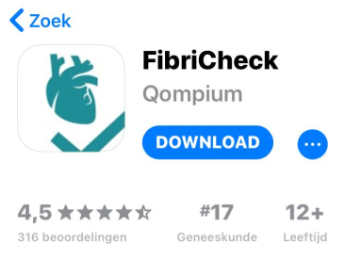
Step one
- Go to the “play store” or the “Apple
App Store” on your smartphone.
- Search the app ‘FibriCheck’ and download the application.

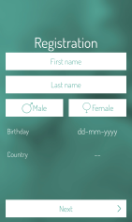
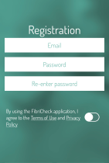
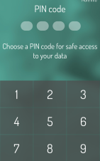
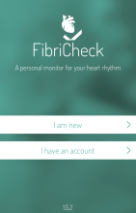
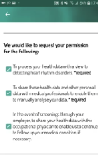

Step two
Create an account. Fill in your own personal data and the email address you provided.

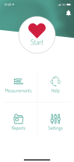
Step three

- To make a registration of the heart rhythm, click “start”
- Place your index finger “gently” on the camera of your smartphone (you do not need to cover the flashlight, this can become hot!). The registrations will start automatically and will take 60 seconds. Afterwards the data is automatically sent to your caregiver.

